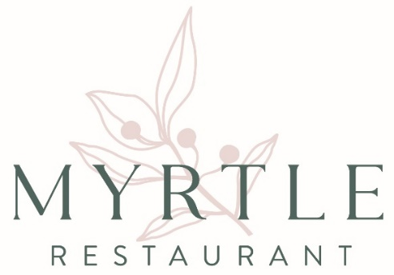

**Céad míle fáilte**

A hundred thousand welcomes

At Myrtle restaurant we celebrate the best of Irish culture, produce and hospitality

**St Patrick’s Menu** 7 COURSE £100

Add wine pairing £90

*Myrtle treacle soda bread & Irish butter*

**Bia Beag**

*Coddle, sausage, bacon, potato*

**Snacks**

*Irish Carlingford oysters*

**Clover** (n)(gf)

*Whipped St Tola, broccoli, pickled Jersey royals*

**Bacon & Cabbage**

*Carrots, white wine velouté, parsley*

**Sirloin of Irish Beef** (gfa)(nfa)

*Burren beef stuffed boxty, portobello mushroom, celeriac, tarragon pesto*

**Milseog Mion** (gfa)(nfa)

*Buttermilk foam, carrot jam, rockscotti crumbs, almonds*

**Dark Hedges** **Gateau** (gf)

*Black cherries, poitín, Aine’s chocolate,* *mascarpone*

**Milsean** (gfa)

*Selection of Irish Fudge to take home*